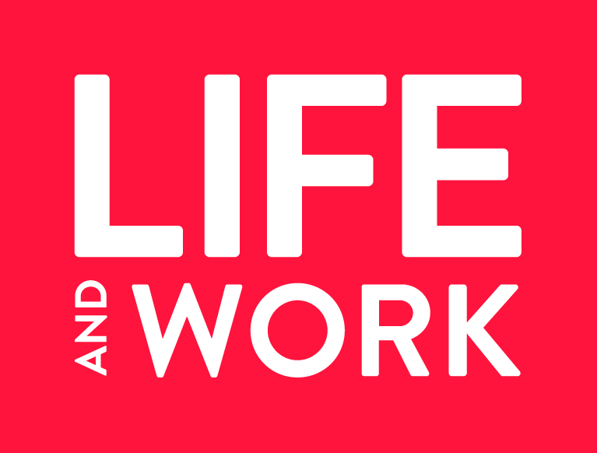

SPECIAL OFFER FOR NEW COMMUNICANTS
THREE FREE ISSUES

Congratulations from Life and Work on becoming a communicant of the Church of Scotland.
You may already be a Life and Work subscriber, but, if not, you will want to be informed about the Church and its work in Scotland and throughout the world. As Scotland’s leading quality magazine and a leader in religious publishing, Life and Work has something for everyone.
We would like to offer you three free issues of Life and Work. To take advantage of this offer, please fill in the form below.
--------------------------------------------------------------------------------------------------------
NAME
ADDRESS

POST CODE
EMAIL ADDRESS
CONGREGATION

Return to admin@lifeandwork.org or Life and Work, Freepost SCO7200, Edinburgh EH2 0BR

