Life and Work Sunday

Life and Work: The Magazine of the Church of Scotland

If there is one individual who can be said to have shaped the Church of Scotland of the 20th century, it is probably the minister and theologian Archibald Charteris (1835-1908).
Charteris, Moderator of the General Assembly in 1892, was instrumental in the founding of the Guild, restoring the office of Deaconess in the Church, and helping to establish the national social care initiative that would evolve into the Social Care Council (CrossReach).
And in amongst all that, he found time to start a magazine.
Charteris, and his Committee on Christian Life and Work, identified that there was a demand for a distinctively Scottish Christian magazine for ministers to circulate in their parishes, complaining that the many English publications were ‘very nearly unintelligible to the untravelled Scot’.
The General Assembly of May 1878 was persuaded, and eight months later Life and Work was born.
Later editors would recall that the new publication faced scepticism and even ridicule from elements of the Church establishment but, distributed through the parish churches with a supplement for local news, Life and Work quickly became part of the furniture and - with the exception of a two-month break because of a printer’s strike in 1959 – it has published monthly ever since.
Typically, Charteris handed over the editorship and moved on to his next project after a year, but by then he had established the template that in many ways remains to this day: news of the Church at local, national and international level, commentary on the key issues of the day from a Scottish Christian perspective, spiritual guidance and Bible study, interviews and profiles of key figures within the Church.
At the union with the United Free Church of Scotland in 1929, the churches’ magazines merged too, becoming ‘Life and Work: the Record of the Church of Scotland’. Colour started to appear on the covers of the 1950s, and the magazine eventually went full colour in 1996.
With the editor answerable only to the General Assembly for the content of the magazine, Life and Work has never been a conventional ‘in-house’ publication or the mouthpiece of the Church hierarchy. Instead, it has been positioned as a critical friend: always wanting the best for the organisation, but free to publish negative opinion or to stray outside the official line.
With the coming of the internet it moved online, firstly on Facebook and Twitter and then with the launch of www.lifeandwork.org, which offers up-to-date news, exclusive features and extracts from the magazine. You can now also read the whole magazine in digital form.
But however you choose to read, Life and Work remains an essential news source and platform for discussion for the whole Church.

Life and Work Sunday

Life and Work – an appreciation

Within the Church of Scotland it is easy to be proud of the fact that we are Presbyterian, when actually, many of us, whether we are aware of it or not, are in fact Congregationalist! For most of the time our focus is on our congregation, our minister and our building. There is nothing wrong with taking the local seriously. Indeed if we don’t the danger is that we become spectators rather than participants. But we shouldn’t stop there. We can be immeasurably enriched as we learn more about other churches, their stories, insights and experience. We can support them in prayer and other ways when they face challenges. We can learn from them and be inspired by them as they take opportunities to do new things or things in a new way..

One of the best ways of learning about the churches that make up the Church of Scotland is by reading Life & Work. Monthly through the post or electronically, and more frequently on social media, it helps its readers to feel part of something bigger than the local church. The articles range over a number of areas. We can read reports on what has been going on or briefings about what is going to happen soon. We are given cameos on places and people within our church or who have taken their faith into the public arena. Issues are discussed and insights given on aspects of the faith. The letters from the reader’s page reminds us how seriously people take their faith and how passionately they feel about it.

I have found over the years that it has enlarged my understanding of the Church I am glad to serve. It is given me material to reflect on that shows the width of our Church. There has been a warmth in it which has meant that I have felt included “as part of the family.” It has helped me keep in touch. It has made me not only part of a Church of Scotland congregation but part of the Church of Scotland.

Very Rev Colin A M Sinclair
Moderator of the General Assembly of the Church of Scotland, 2019

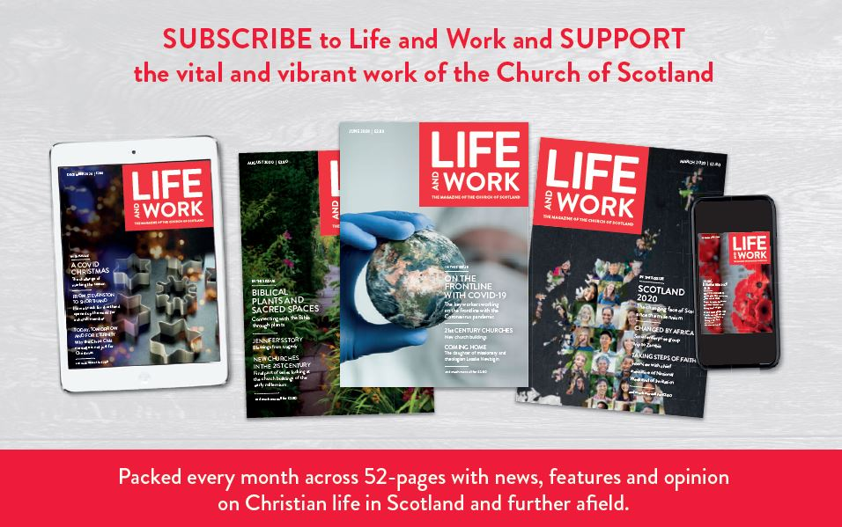

Life and Work Sunday

Special offer

To celebrate Life and Work Sunday and support the magazine of the Church of Scotland we are offering new subscribers the choice of two money saving subscription offers.

Annual PRINT Subscription
Buy 12 issues for the price of 10 and pay ONLY £30
Purchase and save at www.lifeandwork.org/subscribe using promotion code LWS2021

Annual DIGITAL Subscription
Receive 34% OFF when you buy 12 issues and pay ONLY £13.99
Purchase and save at https://pktmags.com/lwspromo

Promotions valid until 30 September 2021

